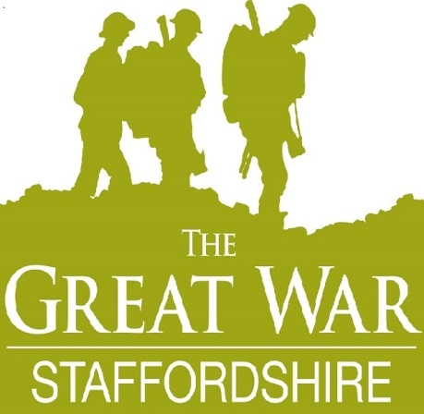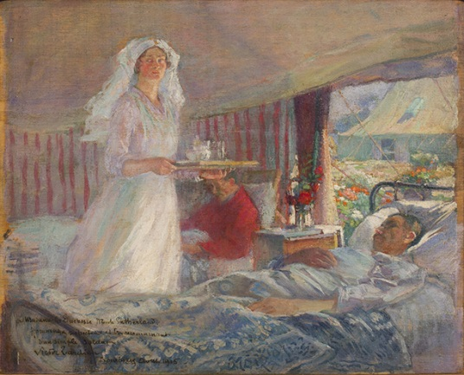

Staffordshire in the Great War : The Impact of War
Saturday 3rd October 2015
County Buildings, Martin Street, Stafford ST16 2LH

Programme
10 Welcome – Janene Cox, Commissioner for Tourism and the Cultural County, Staffordshire County Council
10.15 Identifying medal ribbons – James Whittaker, Staffordshire Regiment Museum
10.40 Horses (cavalry, remounts and requisitioning) – Sarah Elsom, Staffordshire Yeomanry Museum
11.10 Grants for War Memorials - Anna Wilson, Civic Voice (in partnership with the War Memorials Trust)
12.45 – 2 Lunch (not included) – Opportunity to view current projects at the ‘marketplace’ stalls
2.00 Ingestre and Tixall in the Great War/Field Hospital – Successful HLF award – Anne Andrews
2.25 Funding for First World War commemorative projects – Elise Turner, Heritage Lottery Fund
3.00 Guided tour to view the Hospital in the Oatfield exhibition at Shire Hall Gallery and Stafford Library
4.00 End

